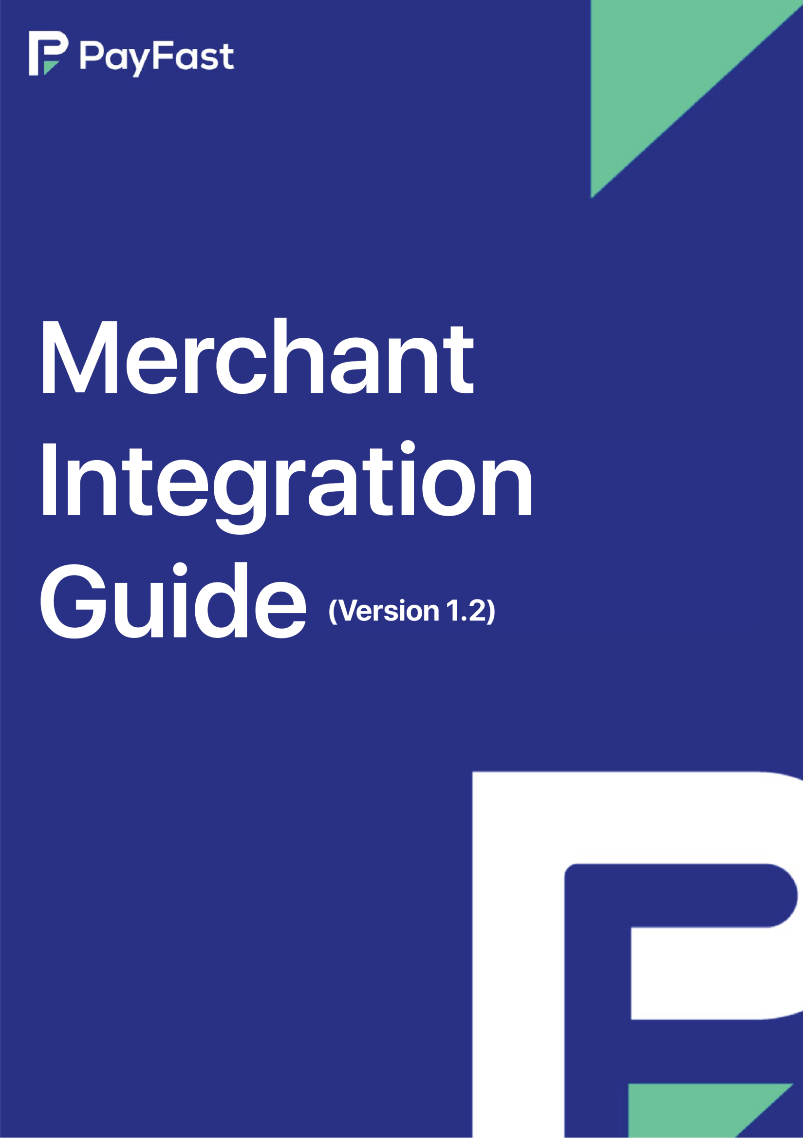



 | 
Ritika Thorani | Junior QA Engineer
Ikram Ul Haq | Senior Service Delivery Engineer



 | 
Syed Yousuf Aziz | Chief Technology Officer

2



 |  |  | 
26th Sep 2020 | S Yousuf Aziz | API End Points | 3.5 and 3.9 added
7th Feb 2020 | S Yousuf Aziz | Error Codes | Error codes update
26th Jan 2021 | Syed Danyal Hassan | Adding Store id in Initiate Transaction via Form POST | 5.2 Initiate Transaction via Form Post  Adding For Redirection implementation with store id
18th Feb 2021 | Syed Danyal Hassan | 5.2 Initiate Transaction via Form Post | Adding Table 1.2
24th Feb 2021 | Syed Danyal Hassan | 5.1 Get An Access Token | Updating Table 1.0 with Basket id and txnamt as optional parameters for getting access token
24th Feb 2021 | Syed Danyal Hassan | 5.2 Initiate Transaction via Form POST request | Updating working code example
16th Apr 2021 | Syed Danyal Hassan | 5.2 Initiate Transaction via Form POST request | Correction in Tran type field name in text field input type and adding respective tran type details

22nd Apr 2021 | Syed Danyal Hassan | Redirection implementation with transaction  type | Adding Redirection implementation with transaction type paragraph

6th May 2021 | Syed Danyal Hassan | Error Codes and Description | Updating Error codes

2nd Sept 2021 | Safdar Abbas | 3.2 Transaction Via Post | Addition of information for checkout URL
23rd Dec 2022 | Ritika Thorani | 3.2 Initiate transaction via post | Addition of form parameters and their responses

- Preface 4
  - About 4
  - Intended Audience 4
  - Integration scope 4
- Introduction 4
  - Payment Flow 5
  - PayFast Checkout Flow 6
    - For redirection implementation 6
  - Merchant Logo/Name setup on PAYFAST gateway page 6
  - Getting Started with PayFast 6
- Technical integration requirements 7
  - Getting an ACCESS TOKEN 7
  - Initiate Transaction via Form POST 8
  - For redirection implementation 9
For Redirection implementation with store ID 14
For Redirection/IPN (backend payment notification) 15
  - Description of mandatory field 16
- Error Codes & Description 17
  - For redirection implementation 19





This document contains detail explanation about how to integrate with PayFast Using Our Hosted Checkout and I-frame based transactions functionality. This document contains the details for online transactions.


This document is for merchants, acquirers and developers who want to integrate with PAYFAST to perform Our Hosted Checkout and I-frame based transactions.



Integration with ecommerce stores or websites will be done by the merchant. PayFast will provide technical assistance in the form of documents and video guides. PayFast will be used only for payment processing.


PayFast payment gateway is a payment service developed for merchants to accept payments from the customers using variety of payment options like bank account, mobile wallets, and card instruments.
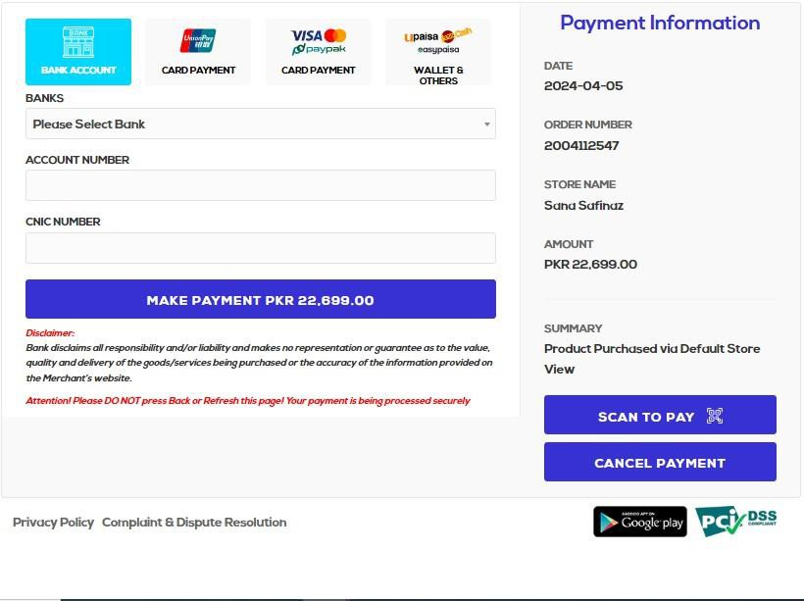

The process begins on the merchant's website, where the customer shops and eventually proceeds to checkout. At this point, they are directed to the PAYFAST payment gateway's web checkout page. There, they enter their payment details like credit/debit card info or bank account number. After that, they may need to confirm the transaction with a one-time password (OTP), ensuring security. Once the OTP is verified, they complete the payment process through PAYFAST. Once the payment is successful, they are redirected back to the merchant's website. Here, the merchant confirms the order, signaling to the customer that their purchase is complete and their order is on its way.


A generic payment flow:
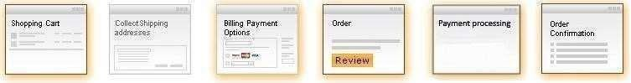

In a typical PAYFAST payment flow, a buyer

- Buyer (customer) adds items in the shopping cart on merchant’s ecommerce portal.
- Buyer reaches checkout page and select the PAYFAST as the payment option.
- Buyer is redirected to PAYFAST payment gateway web checkout page (For Details see section “3” PAYFAST Checkout Flow).
- Buyer Send the correct OTP (one-time password), and completes the payment process. And customer will have redirected towards the same merchant’s ecommerce portal where the customer order is confirmed by merchant if payment is successful.





In the PAYFAST checkout flow, the buyer:
Logged IN user and clicks, “Submit my order” button on the merchant’s ecommerce portal.

  - Order request forward to the PAYFAST checkout page.
  - Buyer select banks and enter their credit, debit, wallet and, account number, and proceed payment.
  - After clicking validate button, transaction request to the selected bank for authentication via OTP from customer.

  - After receiving OTP, customer can enter the OTP, which is provided, by bank on SMS/USSD channel.
  - Returns to Merchant site and confirms the order then receives confirmation.




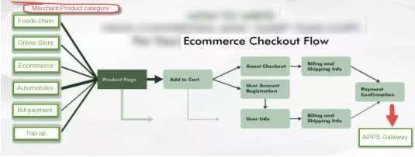

Before the transaction is processed the buyer is taken to a Merchant Logo/Name on PAYFAST payment gateway page, where the buyer’s information is taken, and after submission the order information is displayed. Upon continuation, this page is used to process the transaction with the PAYFAST platform.
The buyer is subsequently taken to the merchant website order confirmation page.
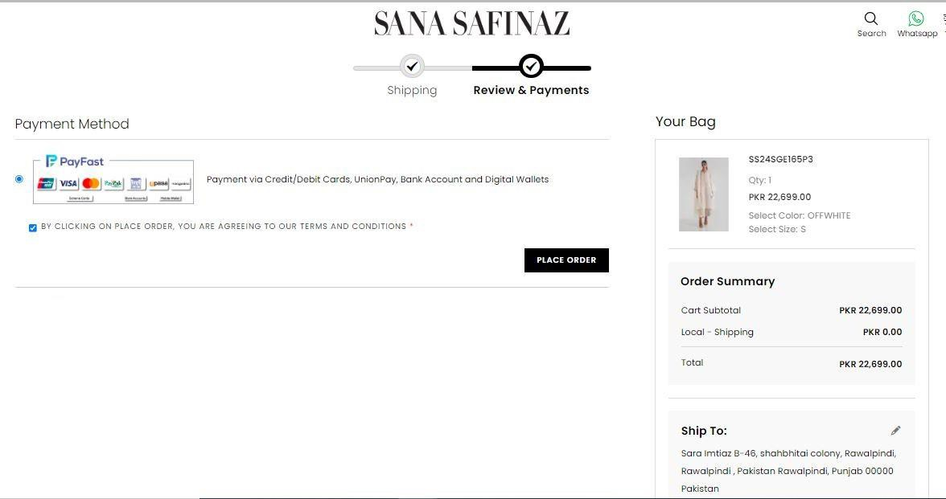




A webhook has to be called to get the access token. Merchant ID, Secure Key, Basket ID, and Transaction amount are the values that will be sent to fetch the access token. Moreover, Empty user agents are not allowed.
Please see below table 1.1.

Table 1.0
URL | https://ipguat.apps.net.pk/Ecommerce/api/Transaction/GetAccessToke n
Method | POST
Parameter s | MERCHANT_ID (Mandatory)
 | SECURED_KEY (Mandatory)
 | BASKET_ID (Mandatory)
 | TXNAMT (Mandatory)
 | CURRENCY_CODE (Mandatory)
Response Type | JSON
Response | {  “MERCHANT_ID”:”<<MERCHANT_ID>>” “ACCESS_TOKEN”:”<<ACCESS_TOKEN>>” “NAME”:”sha”  “GENERATED_DATE_TIME”:”<<GENERATED_DATE_TIME>>”  }





After getting an access token, ecommerce shopping cart will send a FORM POST along with following parameters to PAYFAST payment gate.

Table 1.1
URL for redirection option | https://ipguat.apps.net.pk/Ecommerce/api/Transaction  /PostTransaction
Method | POST
Form Parameters | Description
MERCHANT_ID | A unique ID provided by PAYFAST
MERCHANT_NAME | Brand name
TOKEN | Access token fetched by web hook as mentioned in Table 1.0
PROCCODE | 00/000
TXNAMT | The amount which needs to be paid by the customer  (this should match with the amount sent in the token API)
CUSTOMER_MOBILE_NO | Customer’s mobile number
CUSTOMER_EMAIL_ADDRES S | Customer’s email address
SIGNATURE | A random string value
VERSION | A random string value
TXNDESC | Short description of the goods purchased by customer
SUCCESS_URL | URL where customer will be redirected to in the browser if payment is successful.
FAILURE_URL | URL where customer will be redirected to in the browser if payment is unsuccessful.

BASKET_ID | A unique order id from the merchant, which will represent  customer’s order. (this should match with the Basket ID sent in the token API)
ORDER_DATE [mandatory] | Date of the order.  (Format: YYYY-MM-DD e.g. 2018-01-01)

CHECKOUT_URL | URL payment information or notification is pushed to the merchant at the backend. There are two types of checkout URL immediate(Transaction notification will be pushed immediately) or delayed(Transaction notification will be pushed after a minute)
STORE_ID | Alphanumeric string which would come from merchant portal’s outlet section after outlet creation <optional>
CURRENCY_CODE | PKR <optional>
TRAN_TYPE | Transaction type for settlement <optional>

CUSTOMER_NAME | Customer name from merchant’s web site
MERCHANT_CUSTOMER_ID | Customer ID in merchant’s web site
CUSTOMER_IPADDRESS | Customer IP address at merchant’s web site
COUNTRY | Customer country
SHIPPING_CUSTOMER_NAM E | Customer name for Shipping address
SHIPPING_ADDRESS_1 | Customer shipping address
SHIPPING_ADDRESS_2 | Customer shipping additional address
SHIPPING_STATE_PROVINC E | Shipping state/province
SHIPPING_ADDRESS_CITU | Shipping city
SHIPPING_POSTALCODE | Shipping postal code
SHIPPING_METHOD | Shipping method (Courier, Local Delivery etc)
BILLING_CUSTOMER_NAME | Billing customer name from merchant’s web site
BILLING_ADDRESS_CITY | Billing city of customer
BILLING_ADDRESS_1 | Billing address
BILLING_ADDRESS_2 | Billing additional address
BILLING_STATE_PROVINCE | Billing state/province
BILLING_POSTALCODE | Billing postal code
MERCHANT_USERAGENT | Browser user agent from merchant’s web site
ITEMS | An array (stating from zero) of purchased products from merchant’s web site. S
 | ITEMS[x][SKU]
 | ITEMS[x][NAME]

ITEMS[x][PRICE]

 | ITEMS[x][QTY]
TRAVEL_FIRSTNAME | Traveling customer's first name
TRAVEL_LASTNAME | Traveling customer's last name
TRAVEL_NOOFPASSENGERS | Traveling no of customers
TRAVEL_CARRIERCODE | Traveling customer carrier code
TRAVEL_DESTINATION | Traveling Destination
TRAVEL_DEPARTUREDATE | Traveling departure date
TRAVEL_DEPARTURETIME | Travelling departure time
TRAVEL_ORIGINATION | Travelling origination
TRAVEL_JOURNEYTYPE | Travelling journey type
TRAVEL_ACTUALFINALDEST INATION | Traveling actual destination
PROCESSING_TYPE | "HYBRID_TOKEN" (if a merchant requires a token against a customer-provided instrument used in the current transactions, skip this parameter if not relevant (optional) )

MERCHANT_CUSTOMER_ID | (Customer ID used in merchant's system/application (optional)
INSTRUMENT_TOKEN | "{Token Value}" (needs to provide the instrument token provided (optional
Transaction_Instrument | 1-Bank Account 2-UnionPay  3-visa/MasterCard/paypak(card) 4-wallet  (if a merchant needs only one payment type)


An example PHP code snippet is as follows:
<html>
<body>
<h1>PayFast Example Code For Redirection Payment Request</h1>
<?php
$merchant_id = 102;
$secured_key = 'zWHjBp2AlttNu1sK';
$basket_id = 'ITEM-001'; $trans_amount = 100;
if (count($_GET)
> 0) {
$_GET);
}
processResponse($merchant_id, $basket_id, $trans_amount,
$token = getAccessToken($merchant_id, $secured_key, $basket_id,
$trans_amount);
/**
* get access token with merchant id, secured key, basket id, transaction amount
*
*/

13

function getAccessToken($merchant_id, $secured_key, $basket_id,
$trans_amount)
{
$tokenApiUrl = 'https://ipguat.apps.net.pk/Ecommerce/api/Transaction/GetAccessToken';
$urlPostParams = sprintf( 'MERCHANT_ID=%s&SECURED_KEY=%s&TXNAMT=%s&BASKET_ID=%s',
$merchant_id,
$secured_key,
$trans_amount,
$basket_id
);

$ch = curl_init(); curl_setopt($ch, CURLOPT_URL, $tokenApiUrl); curl_setopt($ch, CURLOPT_RETURNTRANSFER, 1); curl_setopt($ch, CURLOPT_POST, 1); curl_setopt($ch, CURLOPT_POSTFIELDS,
$urlPostParams); curl_setopt($ch, CURLOPT_USERAGENT, 'CURL/PHP PayFast Example');
$response = curl_exec($ch); curl_close($ch);
$payload = json_decode($response);
$token = isset($payload->ACCESS_TOKEN) ? $payload-
>ACCESS_TOKEN : '';
return $token;
}
/**
* process response coming from PayFast
*

echo "<br/>Transaction Failed. Message: " . $err_msg;
}

?>
<!-- For data integrity purpose, transaction amount and basket_id should be the same as the ones sent in token request -->
<!--
Actual Payment Request
-->
<form id='PayFast_payment_form' name='PayFast-payment-form' method='post' action="https://ipguat.apps.net.pk/Ecommerce/api/Transaction/PostTransactio n">
Currency Code: <input type="TEXT" name="CURRENCY_CODE" value="PKR" /><br />
Merchant ID: <input type="TEXT" name="MERCHANT_ID" value="<?php echo $merchant_id; ?>" /><br />
Merchant Name: <input type="TEXT" name="MERCHANT_NAME" value="UAT Demo Merchant" /><br />
Token: <input type="TEXT" name="TOKEN" value="<?php echo $token;
?>" /><br />
Success URL: <input type="TEXT" name="SUCCESS_URL" value="http://merchant-site-example.com" /><br/>
Failure URL: <input type="TEXT" name="FAILURE_URL" value="http://merchant-site-example.com" /><br/>
Checkout URL: <input type="TEXT" name="CHECKOUT_URL" value="http://merchant-site-example.com" /><br/>
Customer Email: <input type="TEXT" name="CUSTOMER_EMAIL_ADDRESS" value="some-email@example.com"
/><br />
Customer Mobile: <input type="TEXT" name="CUSTOMER_MOBILE_NO" value="00000000000" /><br />

15

Transaction Amount: <input type="TEXT" name="TXNAMT" value="<?php echo $trans_amount; ?>" /><br />
Basket ID: <input type="TEXT" name="BASKET_ID" value="<?php echo
$basket_id; ?>" /><br />

Transaction Date: <input type="TEXT" name="ORDER_DATE" value="<?php echo date('Y-m-d H:i:s', time()); ?>" /><br />
Signature: <input type="TEXT" name="SIGNATURE" value="SOMERANDOM-STRING" /><br />
Version: <input type="TEXT" name="VERSION" value="MERCHANTCART- 0.1" /><br />
Item Description: <input type="TEXT" name="TXNDESC" value="Item Purchased from Cart" /><br />
Proccode: <input type="TEXT" name="PROCCODE" value="00" /><br /> Transaction Type: <input type="TEXT" name="TRAN_TYPE"
value='ECOMM_PURCHASE' /><br />
Store ID/Terminal ID (optional): <input type="TEXT" name="STORE_ID" value='102-ZEOJDZS3V' /><br />
Recurring transaction: <input type="TEXT" name="RECURRING_TXN" value="TRUE/FALSE " /><br />
<INPUT TYPE="HIDDEN" NAME="MERCHANT_USERAGENT" value="Mozilla/5.0
(Windows NT 6.1; Win64; x64; rv:47.0) Gecko/20100101 Firefox/47.0">
<INPUT TYPE="HIDDEN" NAME="ITEMS[0][SKU]" value="SAMPLE-SKU-01">
<INPUT TYPE="HIDDEN" NAME="ITEMS[0][PRICE]" value="150"> <INPUT TYPE="HIDDEN" NAME="ITEMS[0][QTY]" value="2">
<INPUT TYPE="HIDDEN" NAME="ITEMS[1][SKU]" value="SAMPLE-SKU-02">
<INPUT TYPE="HIDDEN" NAME="ITEMS[1][NAME]" value="Ice Cream">
<INPUT TYPE="HIDDEN" NAME="ITEMS[1][PRICE]" value="45"> <INPUT TYPE="HIDDEN" NAME="ITEMS[1][QTY]" value="5">

<input type="SUBMIT" value="SUBMIT">
</form>
</body>
</html>

17


Please note that store id is optional but if added as a parameter then it will be validated in our system of which following example is slated below: Store id of sample merchant: 102-ZEOJDZS3V

The payment gateway will send additional parameters (along with those sent already by the merchant) containing transaction information. These parameters are as follows:

Table 1.2
Method | GET
transaction_id | Transaction ID processed at payment gateway
err_code | Status code of the transaction. (‘000’ is for successful transaction)
err_msg | Descriptive message in case of failed transaction
basket_id | Order ID sent by merchant.
order_date [Mandatory] | Date of order sent by merchant.

validation_hash | A SHA256 hash of combination of following fields in particular order:  Basket ID  Merchant Secured Key Merchant ID  Error Code (received from PayFast) String Sequence:  “your_basket_id|your_merchant_secret_key  |your_merchant_id|payasft_err_code”  e.g. BAS-01|jdnkaabcks|102|000  SHA256 of above example will make following hash: e8192a7554dd699975adf39619c703a49239  2edf5e416a61e183866ecdf6a2a2  (please note “|” (pipe) sign is included in the string) Value received from PayFast should match with your calculated hash for data integrity.
PaymentName | Payment type ( account , card , wallet)
discounted_amoun t | Discount given my merchant ( if any )
transaction_amoun t | Actual transaction amount
merchant_amount | Amount sent by merchant
transaction_curren cy | Transaction currency
Instrument_token | Merchant requested token (applies for particular opted service)

19

Recurring_txn | True/False


Mandatory Field | Description
MERCHANT_ID | A unique ID provided by PAYFAST
Merchant_Name | Your brand name
TOKEN | Access token fetched by webhook as mentioned in Table 1.0
PROCCODE | 00 /000
TXNAMT | The amount that needs to be paid by the customer
CUSTOMER_MOBILE_NO | Customer’s mobile number
CUSTOMER_EMAIL_ADDRESS | Customer’s email address
SIGNATURE | A random string value
VERSION | A random string value
TXNDESC | Short description of the goods purchased by customer
SUCCESS_URL | URL where customer will be redirected to in the browser if payment is successful.
FAILURE_URL | URL where customer will be redirected to in the browser if payment is unsuccessful.
BASKET_ID | A unique order id from the merchant that will represent customer’s order.
ORDER_DATE | Date of the order.  (Format: YYYY-MM-DD e.g. 2018-01-01)

CHECKOUT_URL | URL payment information or notification is pushed to the merchant at the backend. There are two types of checkout URL immediate(Transaction notification will be pushed immediately) or delayed (Transaction notification will be  pushed after a minute)

Some new error codes may not exist in the below table

ERROR CODES | ERROR DESCRIPTIONS
000 OR 00 | Processed/Successful Transaction
002 | Time Out
97 | Dear Customer, You have an Insufficient Balance to proceed
106 | Dear Customer, Your transaction Limit has been exceeded please contact your bank
03 | You have entered an Inactive Account
104 | Entered details are Incorrect
55 | You have entered an Invalid OTP/PIN
54 | Card Expired
13 | You have entered an Invalid Amount
126 | Dear Customer your provided Account details are Invalid

21

75 | Maximum PIN Retries has been Exceeded
14 | Dear Customer, You have entered an In- Active Card number
15 | Dear Customer, You have entered an In- Active Card number
42 | Dear Customer, You have entered an Invalid CNIC
423 | Dear Customer, We are unable to process your request at the moment please try again later
41 | Dear Customer, entered details are Mismatched
801 | {0} is your PayFast OTP (One Time Password). Please do not share with anyone.
802 | OTP could not be sent. Please try again later.

803 | OTP has been sent to your email address.
804 | OTP has been sent to your mobile number.
805 | OTP Verified
806 | OTP could not be verified.
807 | Too many attempts. Please try again later in few minutes.
808 | Passwords do not match
809 | Invalid Password

810 | Password could not be changed
811 | Password changed successfully
812 | Request could not be validated. Please try again.
813 | Email address already registered
9000 | FRMS Rejected
9010 | FRMS Error
308 | Dear Customer your provided Account details are Invalid
600 | OTP Already Expired
309 | You have entered Invalid OTP Length
853 | Dear Customer, Your provided Account details are Invalid
04 | You have entered a Closed Account
537 | You have entered a Dormant Account
359 | Blocked Account
8811 | Password changed successfully
880 | Transaction declined due to nonactivation of local ecommerce session. Please call your bank.
881 | Your transaction is declined due to insufficient funds. Please call your bank for assistance

23

882 | Your transaction is declined due to consumption of daily local e_payment transaction limit/count.
883 | Your transaction is declined. Please call your bank to activate local e_payment service





On posting the form data, the customer will be redirected to the following page of the PAYFAST web e- commerce portal.
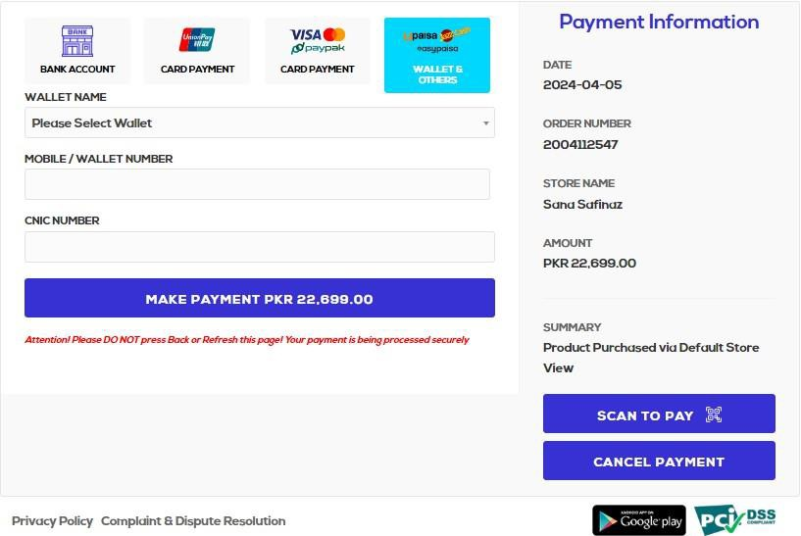

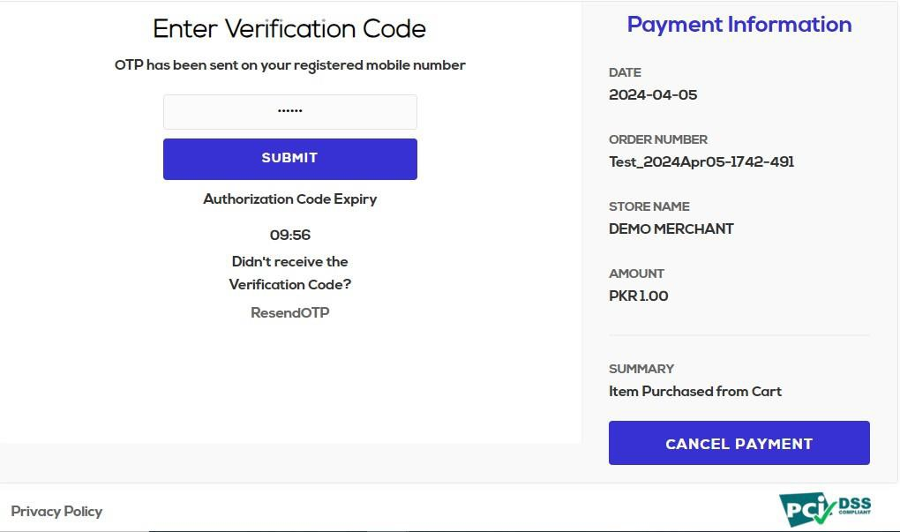

25

